**Project-Title:**

Azure-powered RAG (Retrieval Augmented generation): An Industrial Research Assistant (IRA) and document translation chatbot.

**Input:**

Research Paperss

**Output:**

1. English Summary
2. Japanese Summary
3. Chat with your own pdf
4. English to Japanese Translation

**RAG-ChatGPT:** Retrieval Augmented generation (RAG) chatbot using Azure OpenAI GPT Model, Langchain, ChromaDB, and Gradio.

RAG-GPT supports both PDFs and Docs.

The chatbot offers two convenient ways to use it:

1. Real-time Uploads: You can easily upload documents during your chat sessions, letting the chatbot process and respond to the content immediately.

2. Summarization Requests: You can ask the chatbot to provide a comprehensive summary of an entire PDF or document in a single interaction, making it easy and quick to retrieve information.

**RAG Application Design Schema**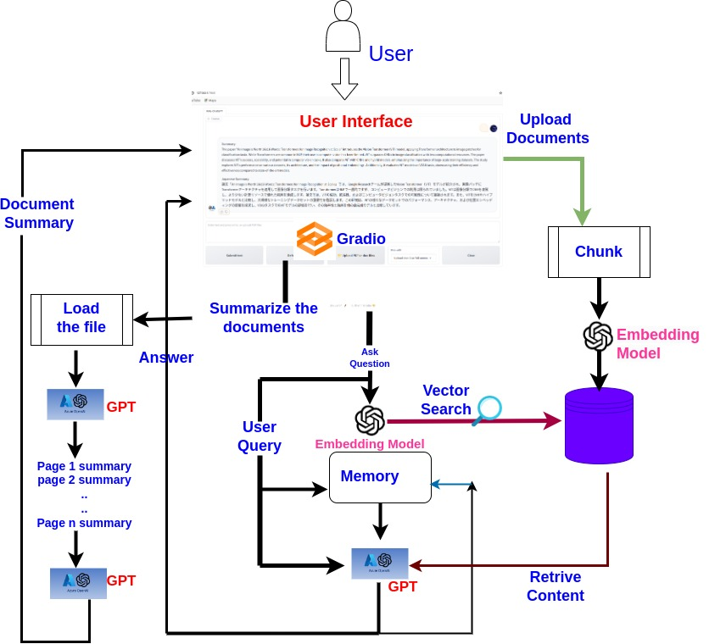

**Document Storage**

Documents are stored in two separate folders within the data directory:

1. data/docs_2: For files that you want to upload.
2. data/docs: For files that should be processed in advance.

Database Creation

Vector databases, also known as vectorDBs, are created and stored in the data folder to enhance the functionality of the project.

**Running the Project:**

To get the project up and running, you'll need to set up your environment and install the necessary dependencies. You can do this by following

1. Go to the **RAG-ChatGPT** folder and locate the requirements.txt file. Install all dependencies using the following command for Ubuntu:

pip install -r requirements.txt

1. First, create the .env file in the parent directory. Refer to the env.example file for details.
2. Open **configs/app_config.yml**, and enter your Azure API embedding model and GPT engine name.
3. Run the Application from the terminal

python src\raggpt_app.py

1. Chat with your documents.

Please refer to the picture below and follow the project details information presented in a step-by-step manner. Kindly review each item carefully to ensure successful completion. Once done, kindly mark each item with a checkmark (✓).

To utilize the project, please follow the following instructions:

1. Download the project and extract it to your personal computer.

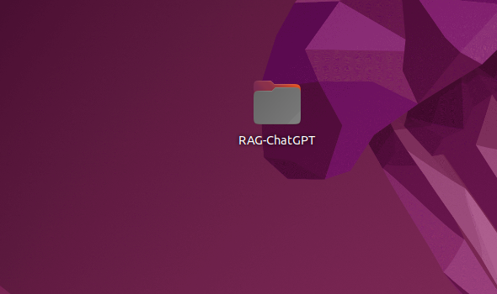

1. Open the project using the Visual Studio Code Integrated Development Environment.

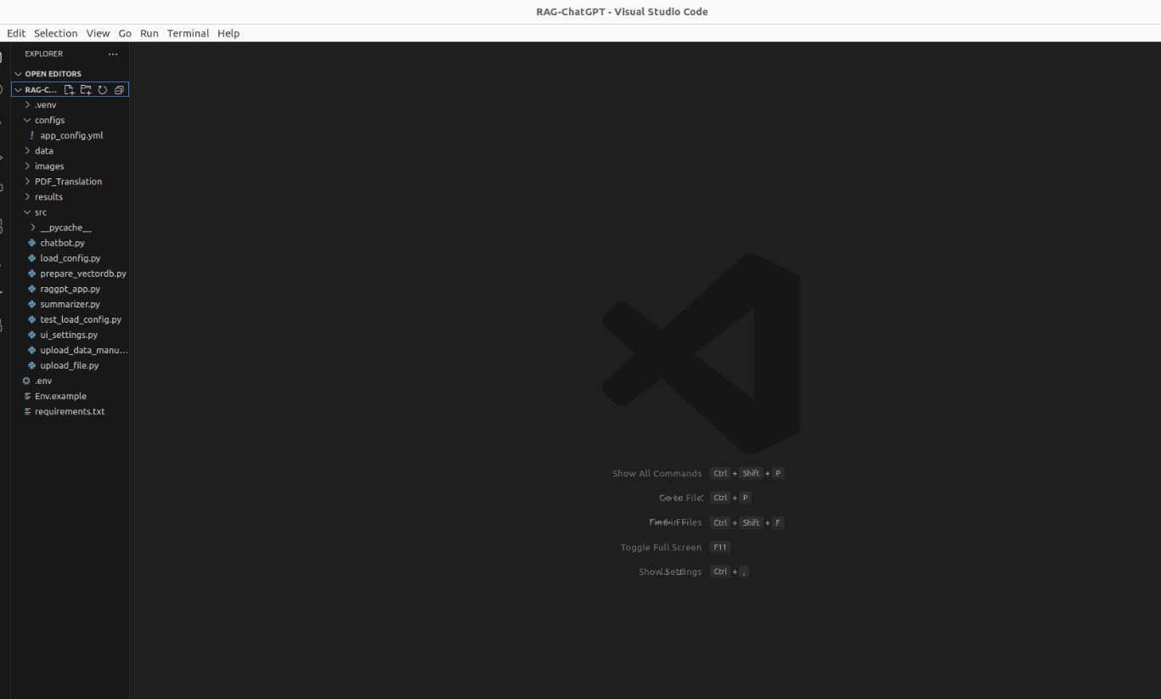

1. Create a .env file in the parent directory and follow the instruction like env.example file.

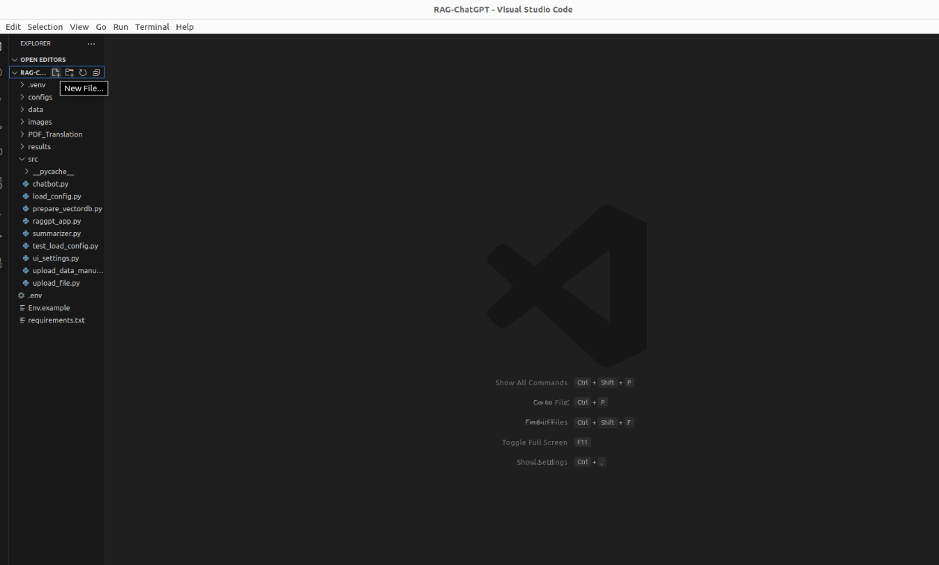

1. Access the app_config.yml file in the configs directory, and input your Azure API embedding model and GPT engine name.

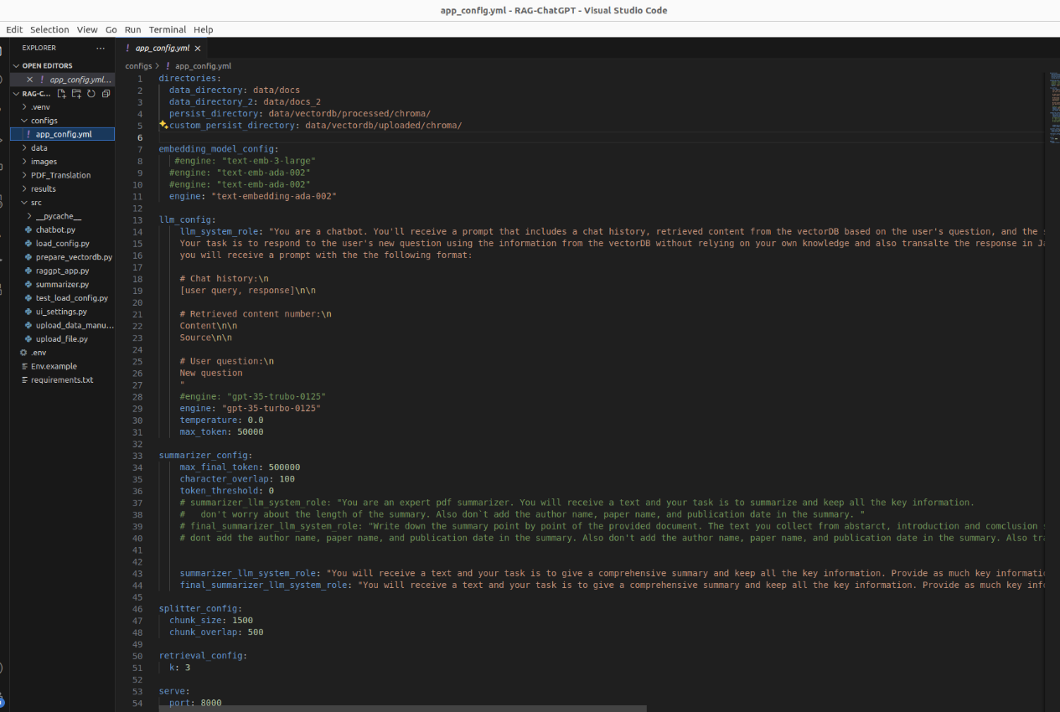

1. If a more concise and enhanced output is desired from the chatbot, please modify the llm_system_role, summarizer_llm_system_role, and final_summarizer_llm_system_role prompts.

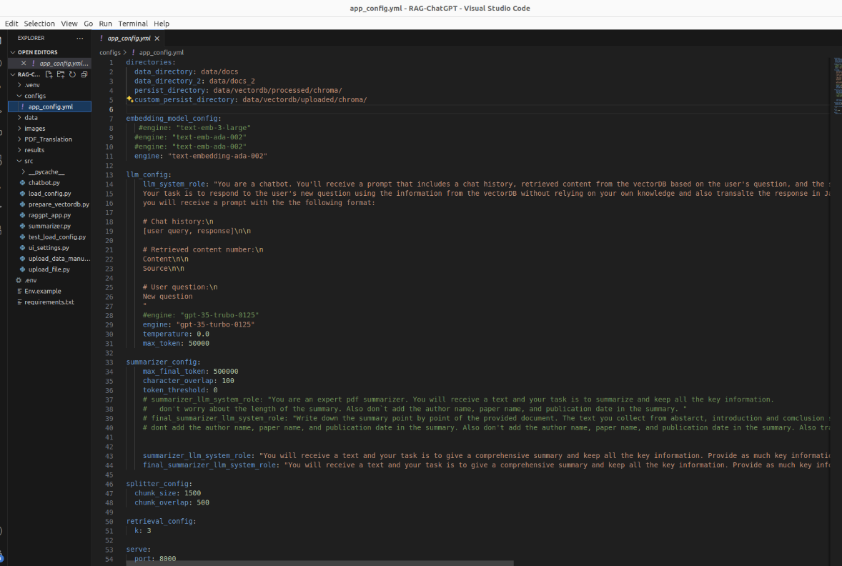

1. Open the raggpt_app.py file in the src folder and run it using the command given below from the terminal.

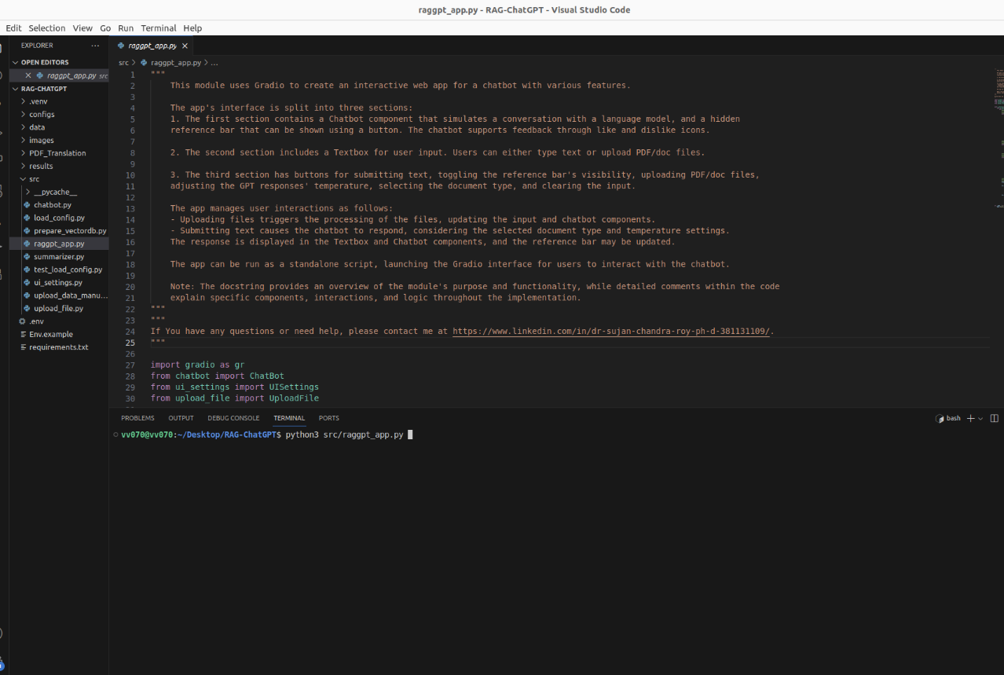

1. Click on the URL by using the Ctrl+click command.

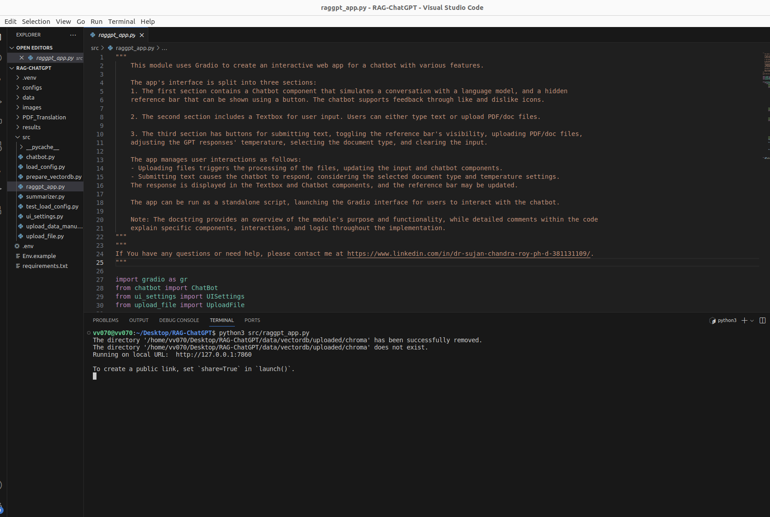

1. The link will then open in your browser.

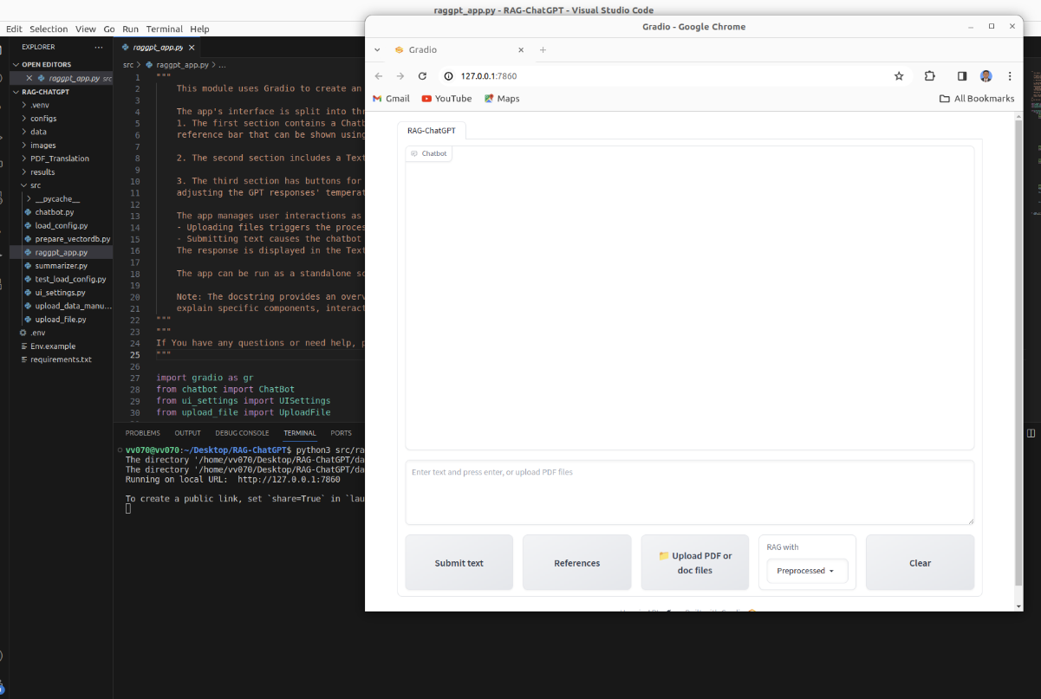

1. Proceed to the "Upload Document" section.

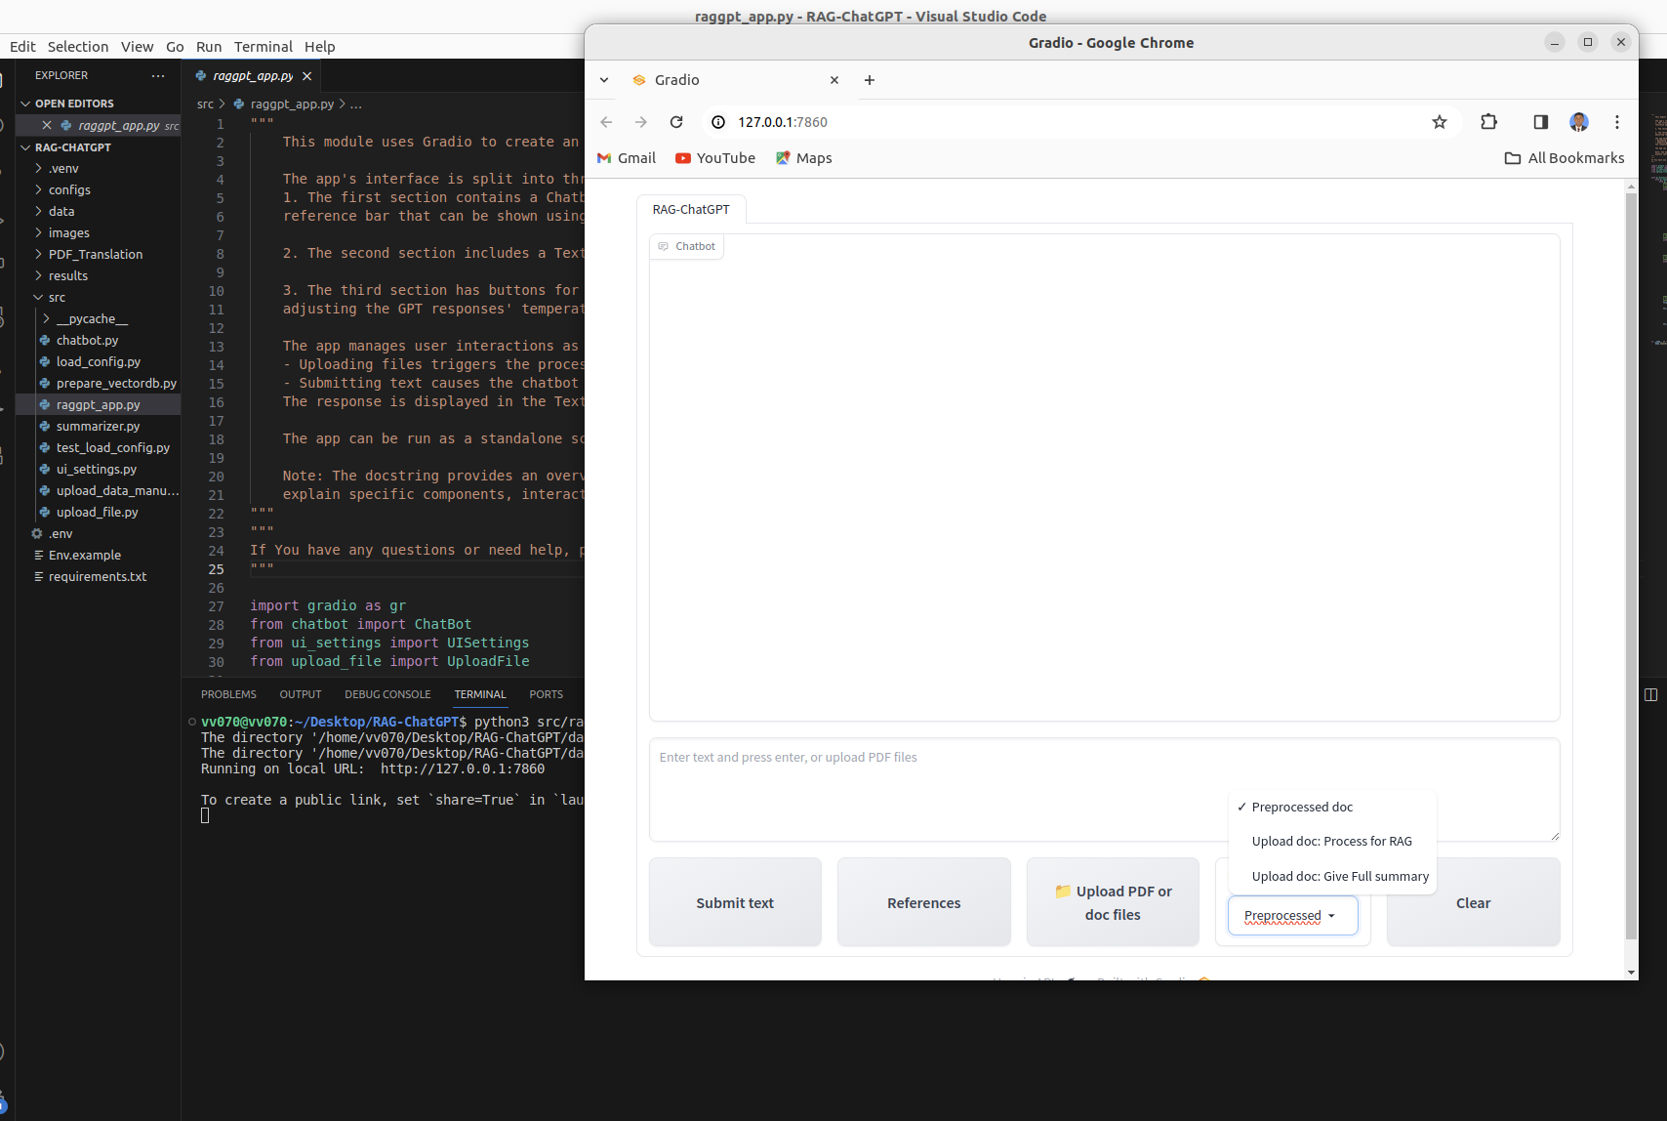

1. Upload the required document for a full summary, and allow some time for the chatbot to display the results automatically.

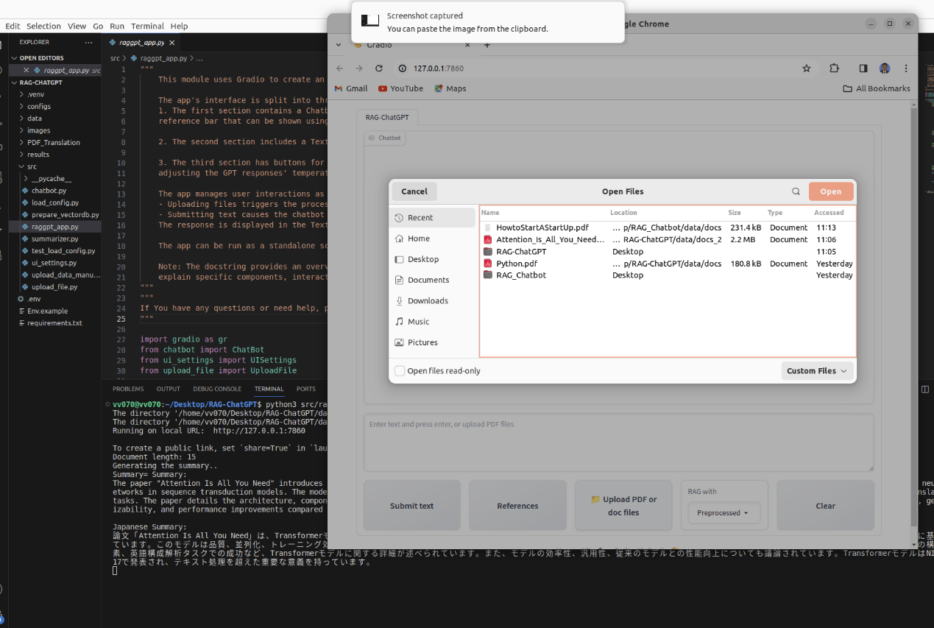

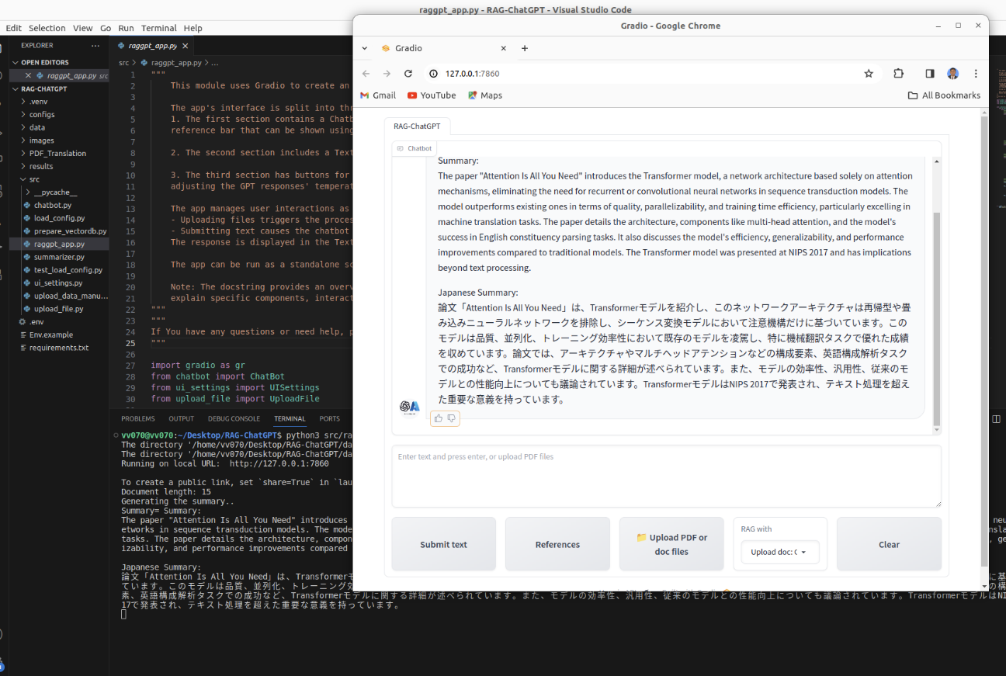

1. Use the "Upload doc: Process for RAG" feature to upload your own document and make inquiries regarding it. The chatbot will display its answer with reference.

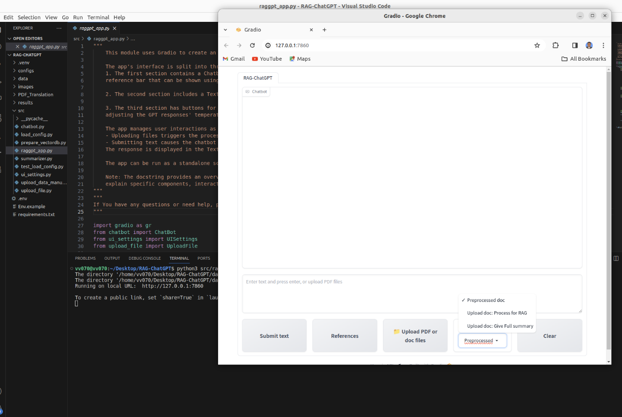

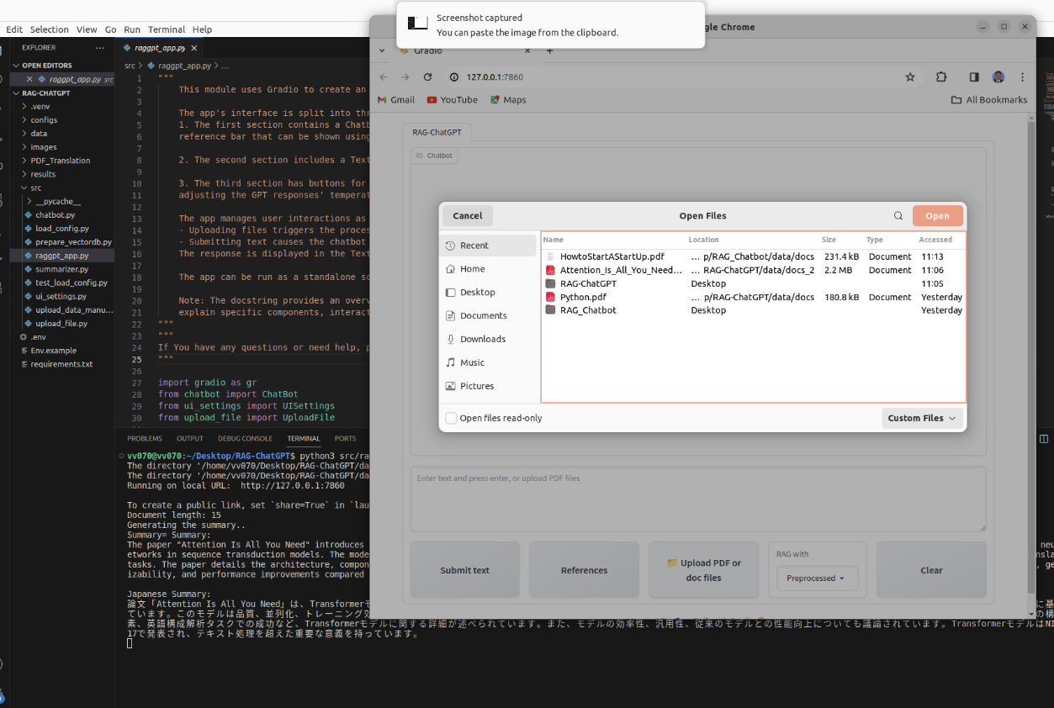

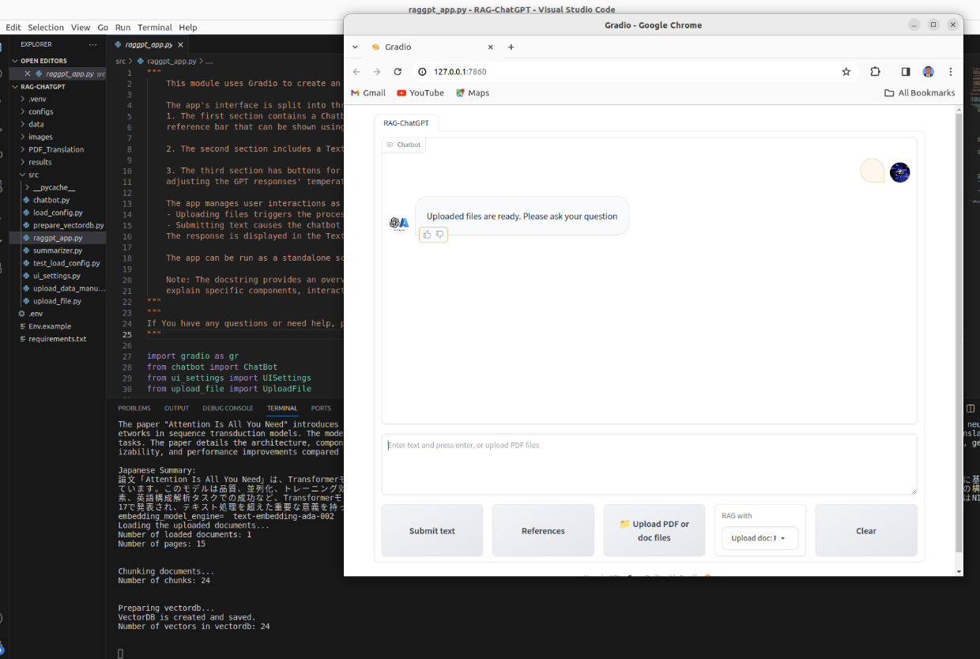

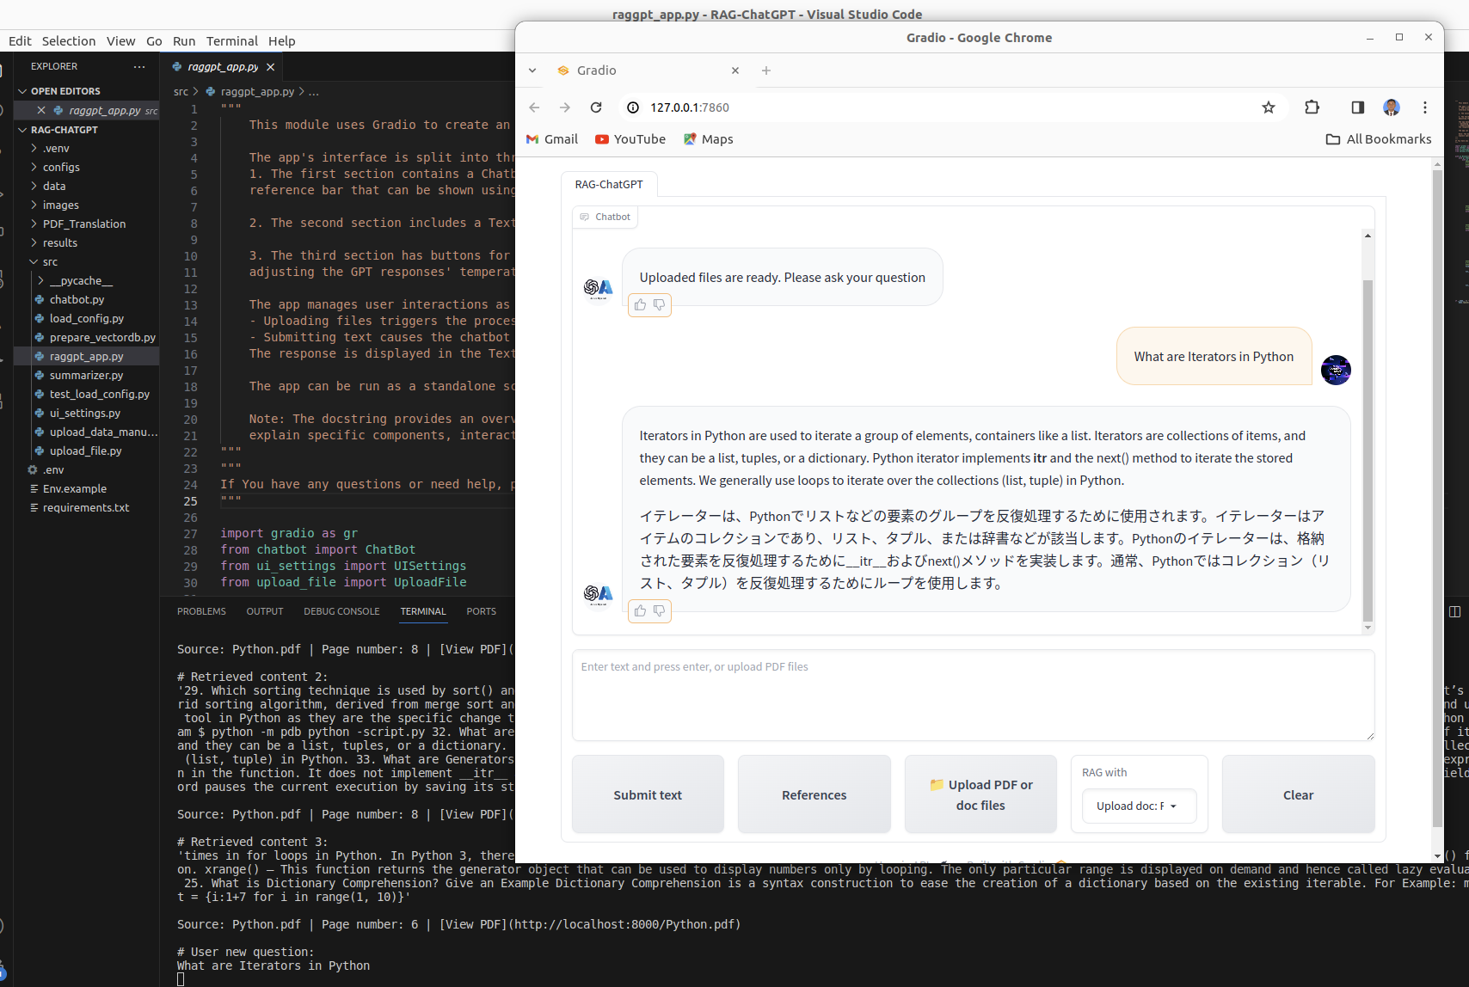



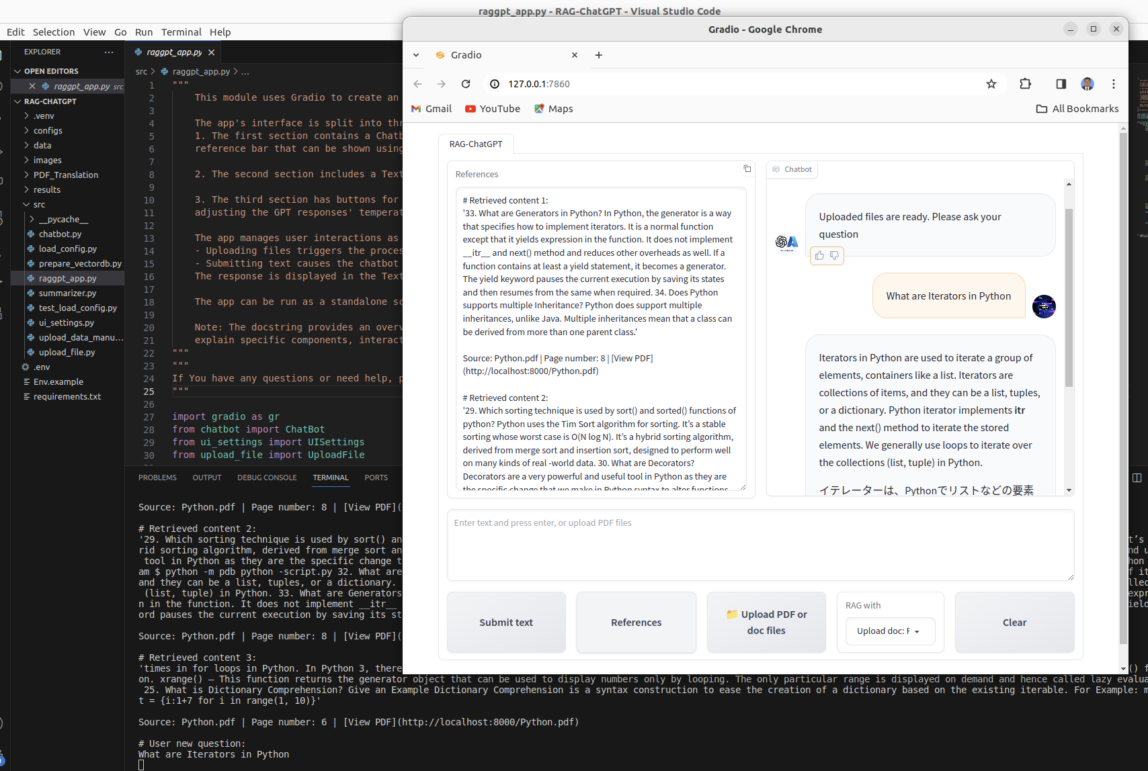

12. Finally, complete the project.

* **Document Translation Project**

In the RAG-GPT folder, there is a folder named pdf_Translation. Inside this folder, you can find another folder named Translated_PDFs. This is where you should put all the documents that you want to have translated into Japanese. To run the program, open the terminal and use the following command:

python PDF_Translation/Translation.py

Once the program has finished running, check the Translated_PDFs folder and you will find the translated document file.

Running Instruction:

To translate your English documents into Japanese using RAG-chatGPT, please follow the steps below:

1. Access the RAG-chatGPT system and navigate to the PDF_Translation folder.

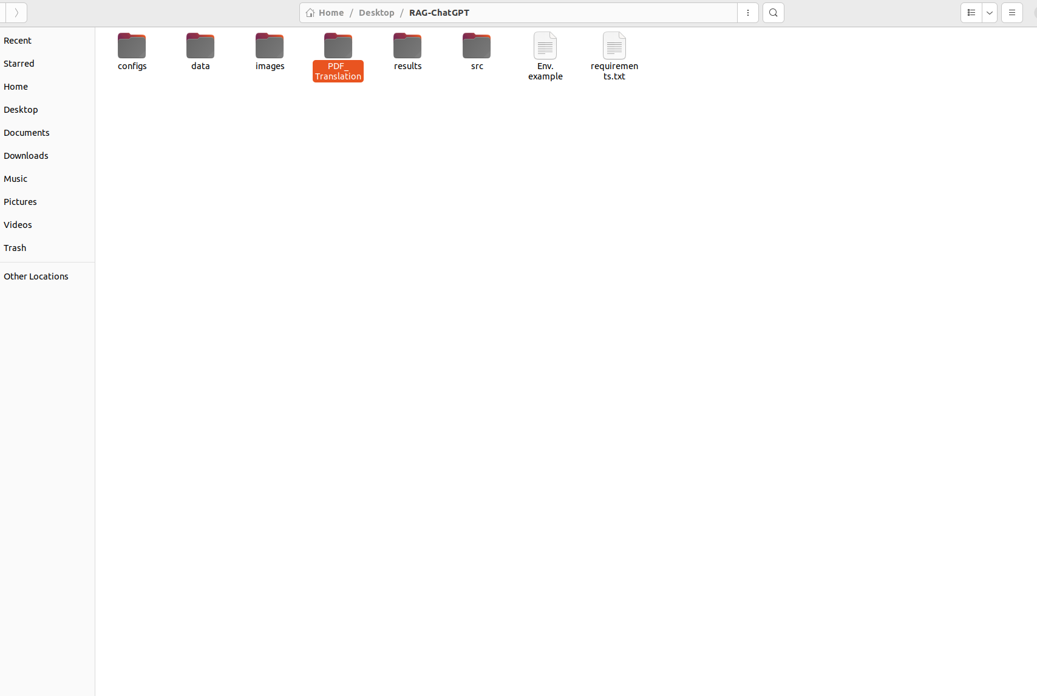

1. Within the PDF_Translation folder, locate the Translated_PDFs folder and place all documents that require translation into this folder.

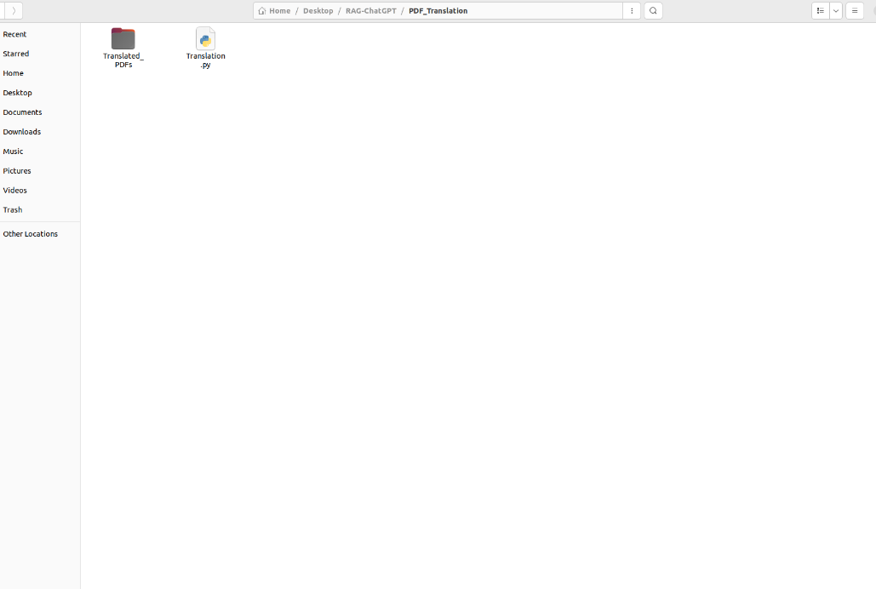

1. Open the PDF_Translation folder in VS Code IDE.

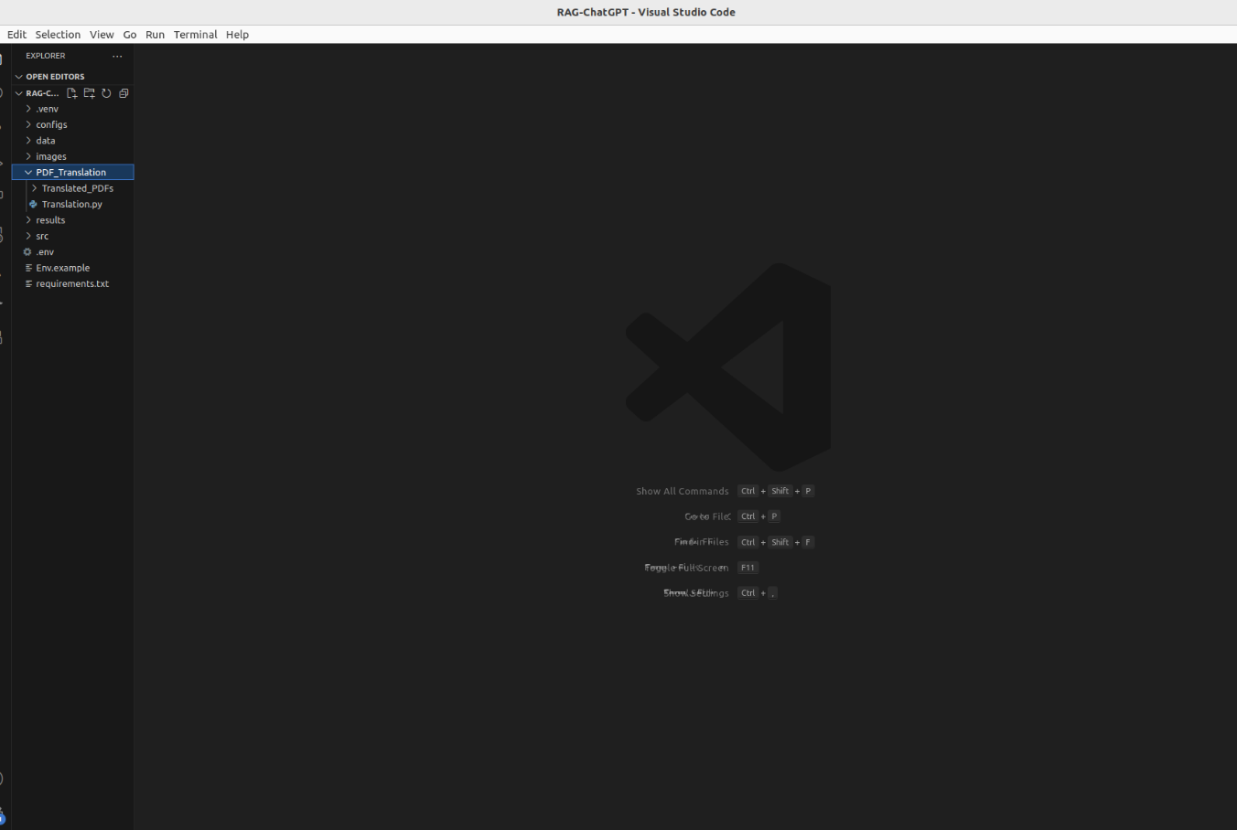

1. Access the Translation.py program.

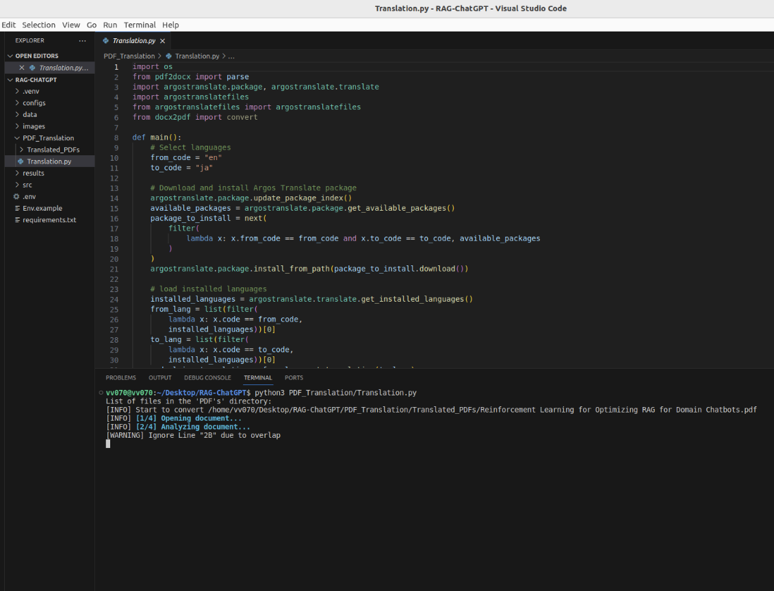

1. Execute the program from the terminal.

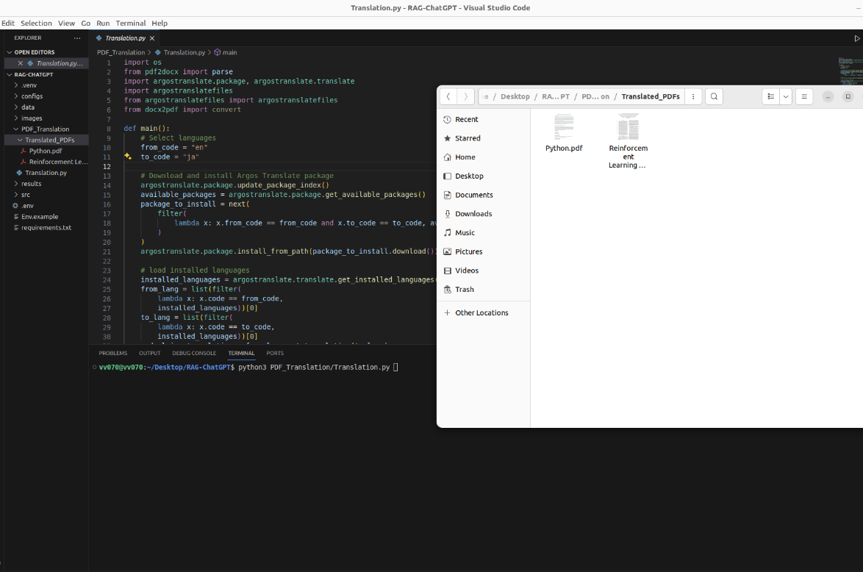

1. Please wait while the program automatically translates your English documents into Japanese.

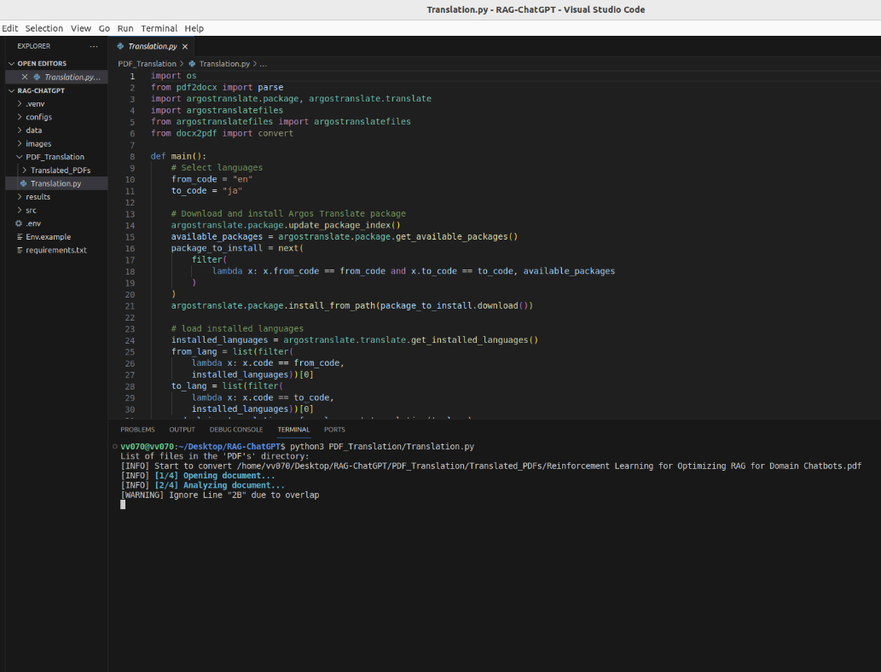

1. Once the program has completed, open the Translated_PDFs folder to find your translated documents.

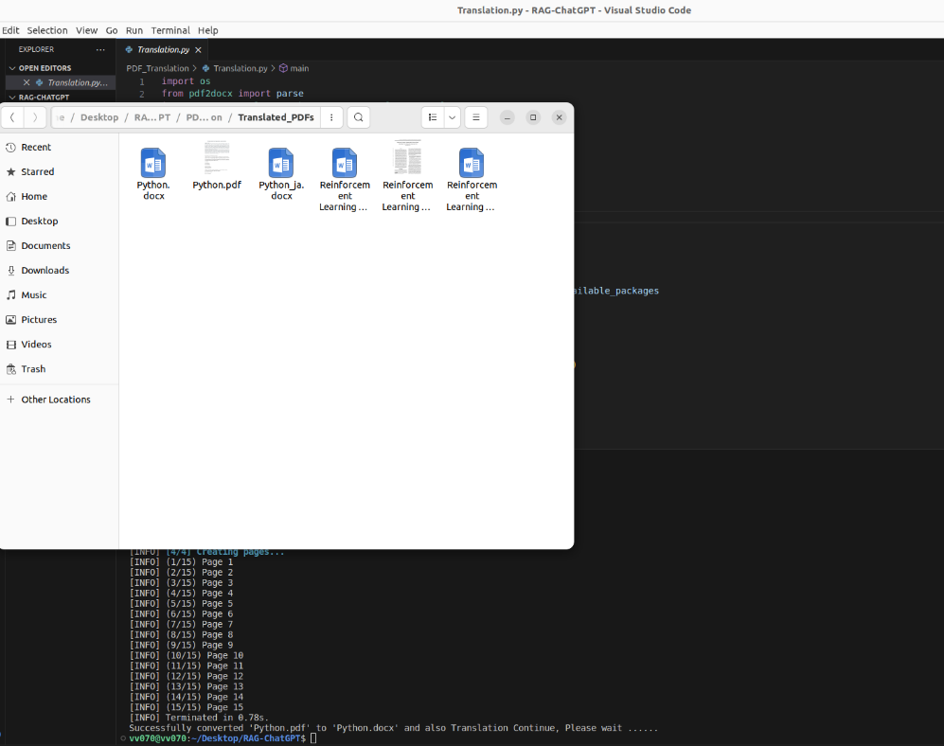

By following these steps, you will be able to easily and accurately translate your English documents into Japanese using the RAG-chatGPT system.